**RECOMMENDATION SYSTEMS IN E-COMMERCE WEBSITES**

By Radhika Bailurkar (2019430003)

Faculty Incharge: Prof. Nataasha Raul

SUMMARY OF PHASE 1

Phase 1gave us perception about the basics of Recommendation Systems, where they were categorized into: Content Filtering, Collaborative Filtering and Hybrid Recommendation Systems. Literature Survey was conducted, which briefly mentioned the algorithms such as linear, clustering and classification algorithms, datasets such as Movie Lens Dataset,etc , content and limitations identified in the Research Papers. Further exploration of Research Papers was initiated in Phase 2

COMPARATIVE ANALYSIS

|  |  |  |  |  |  |
| --- | --- | --- | --- | --- | --- |
| Sr No | Year | Method | Performance Metric | Features | Gaps Identified |
| 1 | 2016 | KMeans , Apriori, kNN | Estimation Values | Business Type Code,Business Name, Estimation Value | Sparsity will result if one customer gives ratings to business that are not frequented by other customers |
| 2 | 2018 | BAT Algorithm(BA, ABC Algos), five fold cross validation | MAE,Precision, Recall, F1 Score, RMSE,  6.9%BA>ABC | Swarm Size, Iteration and Run | In this work, the authors  present a different scheme to conquer collaboration problems by giving weights to items whilst evaluating the similarity between users. The weights are assigned and iteratively improved using the algorithms mentioned. |
| 3 | 2016 | NewRec, TimeRec, HF,CF | MAE and RMSE | Data Sparsity, Influence of Time, Influence of no. of Users, Comparison among algorithms | Influences of context and user interaction behaviour |
| 4 | 2013 | Resnick model, Average model,SR,TR,ST,STR Model | Precision,MAE,RMSE | Preference similarity, recommendation trust, and social relation | Experiment was performed on a small scale. Although the social networking service is increasingly promising, the offered features of social commerce are still limited to prestigious e-commerce sites. |
| 5 | 2007 | MinHash Clustering, PLSI, covisitation counts | Precision-Recall Curve | User click history, Clicked story on News Feed | Increased Cost, Sometimes while analyzing live traffic results may differ acc to Algorithms |
| 6 | 2018 | MLP,CNN | MAE,RMSE | Rating Matrix and Item Review |  |
| 7 | 2018 | PCA, Karhunen-loeve, Discrete Fourier transform | Precision, Recall,  Speedup/Time, F1 metrics, MAE,RMSE | Attributes of user, or of the items or both. | Relevant Variable Selection, Periodicity and Seasonality |
| 8 | 2018 | K-means Algorithm,  Apriori Algorithm | Quality Metrics – confidence distance CD  and recommendation conformity RC | Order ID, Product ID, Product Name | Results were different from expected because of heterogeneous dataset. |
| 9 | 2004 | DC Tree Algorithm, HITS | Recommendation Accuracy, Shortcut Gain | No of Clicks on the website | Incomplete or Limited Information Problem,Incorrect Information Problem, Persistence Problem |
| 10 | 2007 | CBA-CB | Associative Rules, Decision Tree Metrics | Requirement Phrases such as: Stylish, Colorful screen, light,etc | Data fragmentation. Doesnt work well with continuous data. |

DATASET USED IN COMPARATIVE ANALYSIS

1. 8.Korean Business Dataset
2. Jester Dataset comprises of 4.1 million ratings given by 73k users for 100 jokes
3. GroupLens research group in University of Minnesota. There are over 70,000 users and 6,600 rated movies in the database of MovieLens site.
4. Yahoo! Shopping, online shopping website in Taiwan. Data was collected in the form of Questionnaire.
5. a. Movie Lens Dataset consists of movie rating data collected using a web-based research recommender system.

b. The second dataset consists of a subset of clicks received on the Google News website over a certain time period.

c. News Big, contains more records: 500, 000 users, 190, 000 unique items and about 10, 000, 000 clicks.

1. a. MovieLens-1M

b. Amazon Android Apps

c. Amazon Instant Video

d. Amazon Digital Music

1. MovieLens Dataset
2. Kaggle Competition
3. Results from web site of the Computing Science Department of the University of Alberta, Canada. Data was collected for 8 months.
4. Web Database

GAPS IDENTIFIED

(Here the limitations are categorized based on types of Recommendation System)

* Collaborative Filtering

1. Sparsity Problem
2. New Item Problem
3. New User Problem

* Content Filtering

1. Limited Content Analysis
2. Over specialization
3. New User Problem

WORKFLOW MODEL

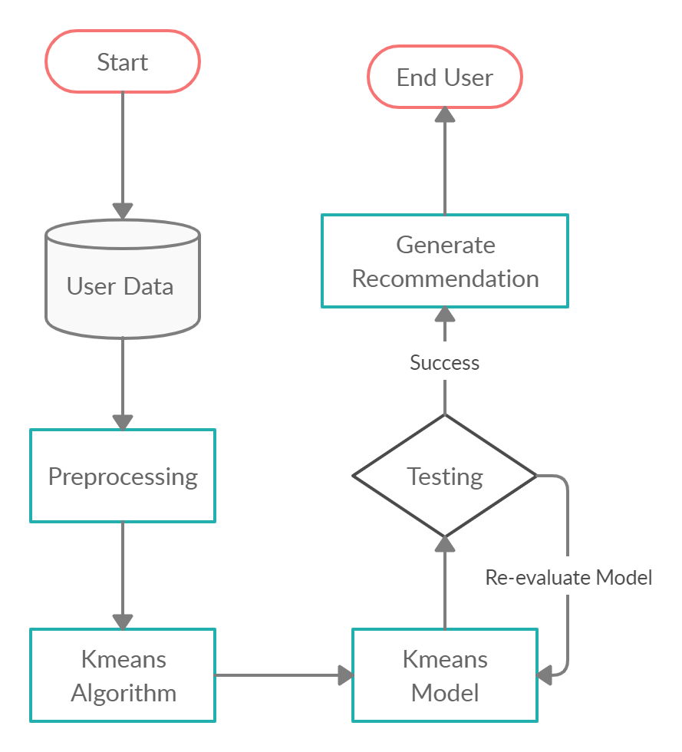

KMEANS ALGORITHM

We are given a data set of items, with certain features, and values for these features The task is to categorize those items into groups. To achieve this, we will use the kmeans algorithm; an unsupervised learning algorithm.K-Means clustering intends to partition *n* objects into *k* clusters in which each object belongs to the cluster with the nearest mean. This method produces exactly *k* different clusters of greatest possible distinction. The best number of clusters *k* leading to the greatest separation (distance) is not known as a priori and must be computed from the data. The objective of K-Means clustering is to minimize total intra-cluster variance, or, the squared error function.

1. Specify number of clusters K.
2. Initialize centroids by first shuffling the dataset and then randomly selecting K data points for the centroids without replacement.
3. Keep iterating until there is no change to the centroids. i.e assignment of data points to clusters isn’t changing.

* Compute the sum of the squared distance between data points and all centroids.
* Assign each data point to the closest cluster (centroid).
* Compute the centroids for the clusters by taking the average of the all data points that belong to each cluster.

**K Means Flowchart**

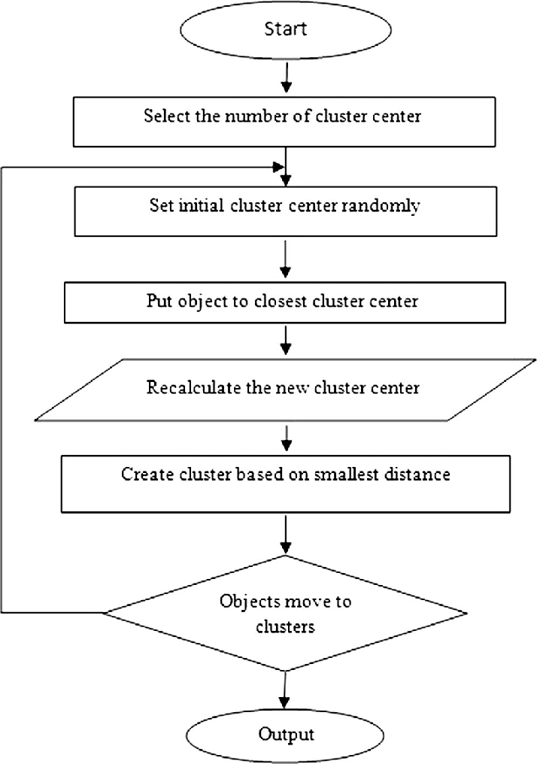

**Kmeans Squared Error Function**

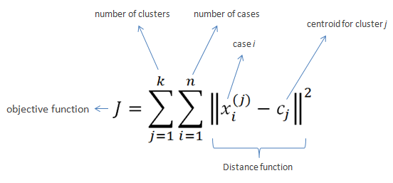

FUTURE PLAN

In Comparative Analysis, we have seen different methods, evaluation metrics and various features implemented in research papers, which gave us insight about how recommendation systems play a role in different settings. We can use this knowlege to futher develop a working prototype which will follow basic functionality of recommendation systems in websites. I will develop a Recommender Model based on ‘Kmeans Algorithm’ which will adhere to the required evaluation/performance metric.

REFERENCES

1. JinHyun Joo, SangWon Bang, GeunDuk Park, ”Implementation of a Recommendation System using Association Rules and Collaborative Filtering”, *Information Technology and Quantitative Management (ITQM 2016)*, 2016
2. Sambhav Yadav, Sushama Nagpal, “An Improved Collaborative Filtering Based Recommender System using Bat Algorithm”*, International Conference on Computational Intelligence and Data Science (ICCIDS 2018)*,2018
3. Zhijun Zhang, Gongwen Xu, and Pengfei Zhang, ”Research on E-Commerce Platform-Based Personalized Recommendation Algorithm”, *Applied Computational Intelligence and So Computing*,2016
4. Yung-Ming Li, Chun-Te Wu, Cheng-Yang Lai, ”A social recommender mechanism for e-commerce: Combining similarity, trust and relationship”, *Decision Support Systems*,2013
5. Abhinandan Das, Mayur Datar, Ashutosh Garg, ”Google News Personalization: Scalable Online Collaborative Filtering”, *Track: Industrial Practice and Experience*,2007
6. Meshal Alfarhood, Jianlin Cheng, ”DeepHCF: A Deep Learning Based Hybrid Collaborative Filtering Approach for Recommendation Systems”, *17th IEEE International Conference on Machine Learning and Applications*, 2018
7. Janani Balasubramanian, Soumya Koppaka, Chinmay Rane, and Nataasha Raul, ”Parameter Based Survey of Recommendation Systems”, 2018
8. Kutuzova Tatiana, Melnik Mikhail, “Market basket analysis of heterogeneous data sources for recommendation system improvement”, *7th International Young Scientist Conference on Computational Sciences*, 2018
9. Jia Li and Osmar R Zaiane, ”Combining Usage, Content, and Structure Data to Improve Web Site Recommendation”, 2004
10. Xi-Zheng Zhang, "Building Personalized Recommendation System in E-Commerce using Association Rule-Based Mining and Classification," *2007 International Conference on Machine Learning and Cybernetics, Hong Kong*, 2007, pp. 4113-4118.
11. Gediminas Adomavicius, and Alexander Tuzhili, ”Towards the Next Generation of Recommender Systems:A Survey of the State-of-the-Art and Possible Extensions”
12. Neha Verma, Devanand, Bhavna Arora, ”Experimental Analysis of Recommendation System in e-Commerce”, *International Journal of Innovative Technology and Exploring Engineering (IJITEE),ISSN: 2278-3075, Volume-8 Issue-8S3*, June 2019
13. J. Ben Schafer, Joseph A. Konstan, John Riedl,”E-Commerce Recommendation Applications”,*E-Commerce Recommender Applications*
14. Francisco, G. S., Rafael,”An integrated approach for developing e-commerce applications”,  *Expert Systems with Applications*, 2005
15. Xiaojun, Liu, “An improved clustering based collaborative filtering recommendation algorithm”,*Cluster Computing*,2017

